**2. Spam Classification**

Many email services today provide spam filters that are able to classify emails into spam and non-spam email with high accuracy. In this part of the exercise, you will use SVMs to build your own spam filter. You will be training a classifier to classify whether a given email, *x*, is spam () or non-spam (). In particular, you need to convert each email into a feature vector . The following parts of the exercise will walk you through how such a feature vector can be constructed from an email.

The dataset included for this exercise is based on a a subset of the [SpamAssassin Public Corpus](https://spamassassin.apache.org/old/publiccorpus/). For the purpose of this exercise, you will only be using the body of the email (excluding the email headers).

**2.1 Preprocessing emails**

Before starting on a machine learning task, it is usually insightful to take a look at examples from the dataset. Figure 8 shows a sample email that contains a URL, an email address (at the end), numbers, and dollar amounts. While many emails would contain similar types of entities (e.g., numbers, other URLs, or other email addresses), the specific entities (e.g., the specic URL or specific dollar amount) will be different in almost every email.

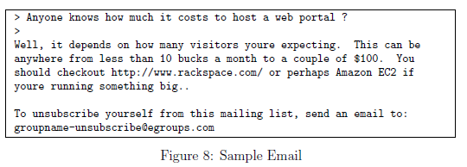

Therefore, one method often employed in processing emails is to 'normalize' these values, so that all URLs are treated the same, all numbers are treated the same, etc. For example, we could replace each URL in the email with the unique string "httpaddr" to indicate that a URL was present. This has the effect of letting the spam classifier make a classification decision based on whether any URL was present, rather than whether a specific URL was present. This typically improves the performance of a spam classifier, since spammers often randomize the URLs, and thus the odds of seeing any particular URL again in a new piece of spam is very small.

In processEmail.m, we have implemented the following email preprocessing and normalization steps:

* Lower-casing: The entire email is converted into lower case, so that captialization is ignored (e.g., IndIcaTE is treated the same as indicate).
* Stripping HTML: All HTML tags are removed from the emails. Many emails often come with HTML formatting; we remove all the HTML tags, so that only the content remains.
* Normalizing URLs: All URLs are replaced with the text "httpaddr".
* Normalizing Email Addresses: All email addresses are replaced with the text "emailaddr".
* Normalizing Numbers: All numbers are replaced with the text 'number'.
* Normalizing Dollars: All dollar signs ($) are replaced with the text 'dollar'.
* Word Stemming: Words are reduced to their stemmed form. For example, 'discount', 'discounts', 'discounted' and 'discounting' are all replaced with 'discount'. Sometimes, the Stemmer actually strips off additional characters from the end, so 'include', 'includes', 'included', and 'including' are all replaced with 'includ'.
* Removal of non-words: Non-words and punctuation have been removed. All white spaces (tabs, newlines, spaces) have all been trimmed to a single space character.

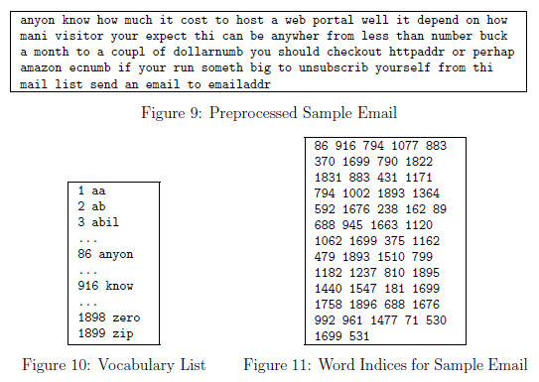

The result of these preprocessing steps is shown in Figure 9. While preprocessing has left word fragments and non-words, this form turns out to be much easier to work with for performing feature extraction.

**2.1.1 Vocabulary list**

After preprocessing the emails, we have a list of words (e.g., Figure 9) for each email. The next step is to choose which words we would like to use in our classifier and which we would want to leave out. For this exercise, we have chosen only the most frequently occuring words as our set of words considered (the vocabulary list). Since words that occur rarely in the training set are only in a few emails, they might cause the model to overfit our training set. The complete vocabulary list is in the file vocab.txt and also shown in Figure 10. Our vocabulary list was selected by choosing all words which occur at least a 100 times in the spam corpus, resulting in a list of 1899 words. In practice, a vocabulary list with about 10,000 to 50,000 words is often used.

Given the vocabulary list, we can now map each word in the preprocessed emails (e.g., Figure 9) into a list of word indices that contains the index of the word in the vocabulary list. Figure 11 shows the mapping for the sample email. Specically, in the sample email, the word 'anyone' was first normalized to 'anyon' and then mapped onto the index 86 in the vocabulary list.

Your task now is to complete the code in processEmail.m to perform this mapping. In the code, you are given a string str which is a single word from the processed email. You should look up the word in the vocabulary list vocabList and find if the word exists in the vocabulary list. If the word exists, you should add the index of the word into the word indices variable. If the word does not exist, and is therefore not in the vocabulary, you can skip the word.

Once you have implemented processEmail.m, the code below will run your code on the email sample and you should see an output similar to Figures 9 & 11.

**MATLAB Tip**: In MATLAB, you can compare two strings with the strcmp function. For example, strcmp(str1, str2) will return 1 only when both strings are equal. In the provided starter code, vocabList is a 'cell-array' containing the words in the vocabulary. In MATLAB, a cell-array is just like a normal array (i.e., a vector), except that its elements can also be strings (which they can't in a normal MATLAB matrix/vector), and you index into them using curly braces instead of square brackets. Specically, to get the word at index i, you can use vocabList{i}. You can also use length(vocabList) to get the number of words in the vocabulary.

%% Initialization

clear;

% Extract Features

file_contents = readFile('emailSample1.txt');

word_indices = processEmail(file_contents);

==== Processed Email ====  
  
anyon know how much it cost to host a web portal well it depend on how mani   
visitor you re expect thi can be anywher from less than number buck a month   
to a coupl of dollarnumb you should checkout httpaddr or perhap amazon ecnumb   
if your run someth big to unsubscrib yourself from thi mail list send an   
email to emailaddr   
  
=========================

% Print Stats

disp(word_indices)

**2.2 Extracting features from emails**

You will now implement the feature extraction that converts each email into a vector in . For this exercise, you will be using words in vocabulary list. Specically, the feature for an email corresponds to whether the *i*-th word in the dictionary occurs in the email. That is,  if the *i*-th word is in the email and  if the *i*-th word is not present in the email.

Thus, for a typical email, this feature would look like:

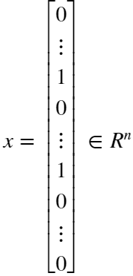

You should now complete the code in emailFeatures.m to generate a feature vector for an email, given the word indices. Once you have implemented emailFeatures.m, the code below will will run your code on the email sample. You should see that the feature vector had length 1899 and 45 non-zero entries.

% Extract Features

features = emailFeatures(word_indices);

% Print Stats

fprintf('Length of feature vector: %d\n', length(features));

Length of feature vector: 1899

fprintf('Number of non-zero entries: %d\n', sum(features > 0));

Number of non-zero entries: 45

**2.3 Training SVM for spam classification**

After you have completed the feature extraction functions, the code in this section will load a preprocessed training dataset that will be used to train an SVM classifier. spamTrain.mat contains 4000 training examples of spam and non-spam email, while spamTest.mat contains 1000 test examples. Each original email was processed using the processEmail and emailFeatures functions and converted into a vector . After loading the dataset, the code will proceed to train a SVM to classify between spam () and non-spam () emails. Once the training completes, you should see that the classifier gets a training accuracy of about 99.8% and a test accuracy of about 98.5%.

% Load the Spam Email dataset

% You will have X, y in your environment

load('spamTrain.mat');

C = 0.1;

model = svmTrain(X, y, C, @linearKernel);

Training ......................................................................  
...............................................................................  
...............................................................................  
................................................ Done!

p = svmPredict(model, X);

fprintf('Training Accuracy: %f\n', mean(double(p == y)) * 100);

Training Accuracy: 99.850000

% Load the test dataset

% You will have Xtest, ytest in your environment

load('spamTest.mat');

p = svmPredict(model, Xtest);

fprintf('Test Accuracy: %f\n', mean(double(p == ytest)) * 100);

Test Accuracy: 98.800000